Homework 1 (2014)
Title : Hangman Game
Due Date: Week 9 (during practical class)

Description :
In this homework, you are required to create a simple Hangman game. Hangman is a word game where one player thinks of a word and another player tries to guess it by suggesting letters. If the player cannot guess the correct word in a certain number of guesses, then he or she loses.
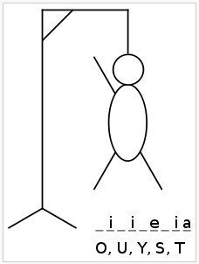

Example of Hangman(Source: Wikipedia)

In this homework, you should create 2 main features for the game:
- Setup the data list
In this feature, you should ask user for the data list’s size and also ask the user to enter the data into an ArrayList. Note: You should only use the ArrayList in this part and not Array. After user entered the required information, the user will then start the game by choosing the option 2. ONE of the words entered should be randomly selected for the game when user plays the game.

Sample output
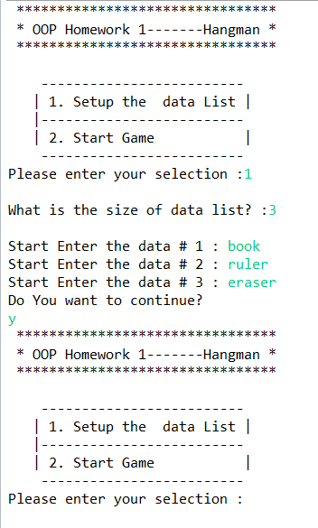

- Play the Hangman
Allow the user to start playing the game and your program should display the Hangman puzzle game if the user does not get the correct guesses. Each user should have 5 times of chances to guess the correct word.
Sample output
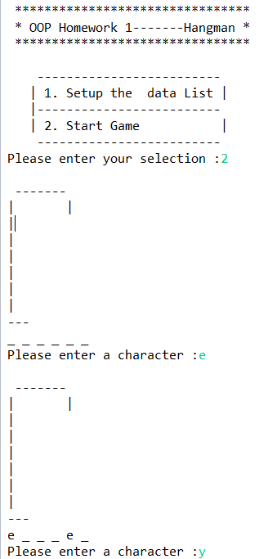
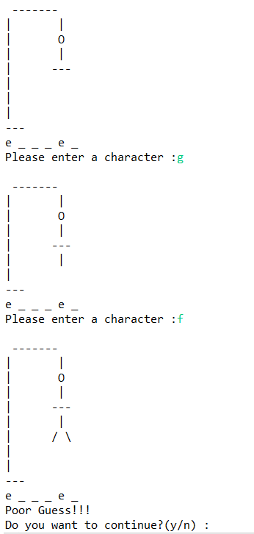

Requirements
- Must have Tester program
- Must use ArrayList to store data list
- Must allow user to continue after the game finished
- You should determine either Case Sensitivity is important in your program
- You may determine the scope of your data list (eg:- animal, car, stationary)

NOTE: Discussion is allowed in the homework, BUT COPY/SHARING of work is STRICTLY NOT ALLOWED. 0 mark will be grant to all the similar work found.

